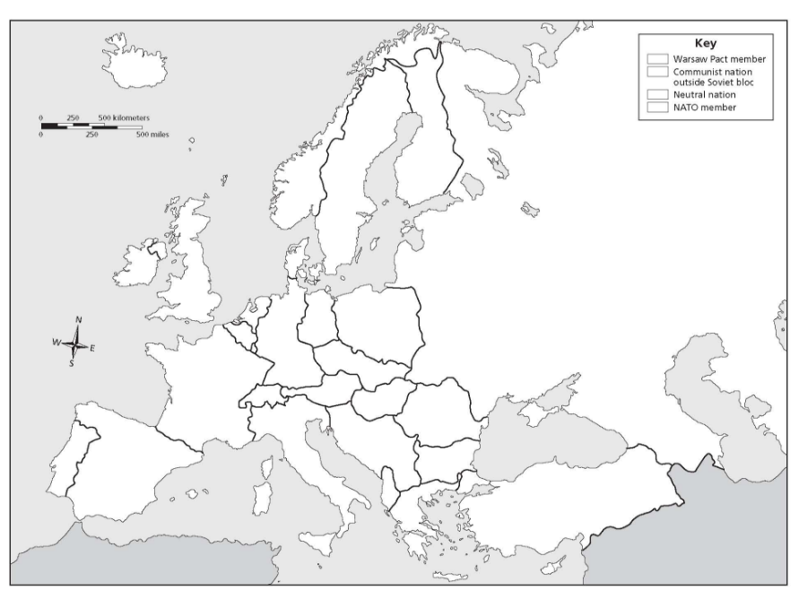

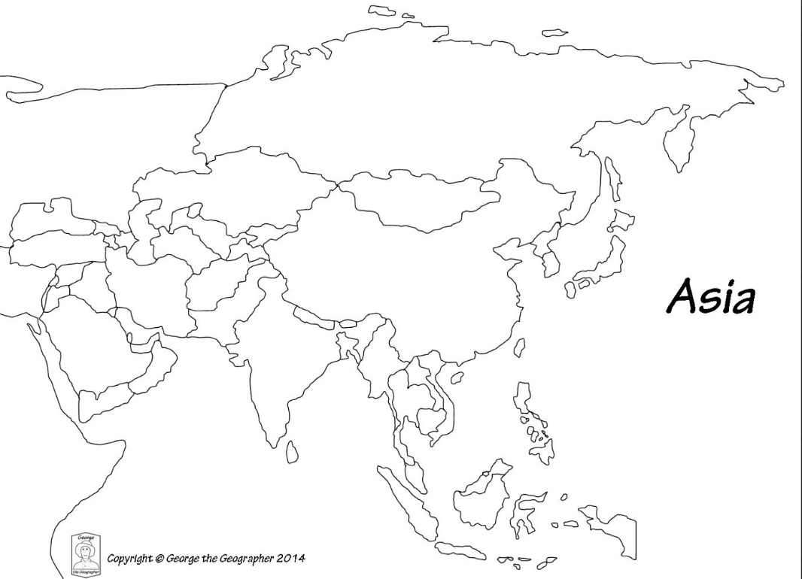
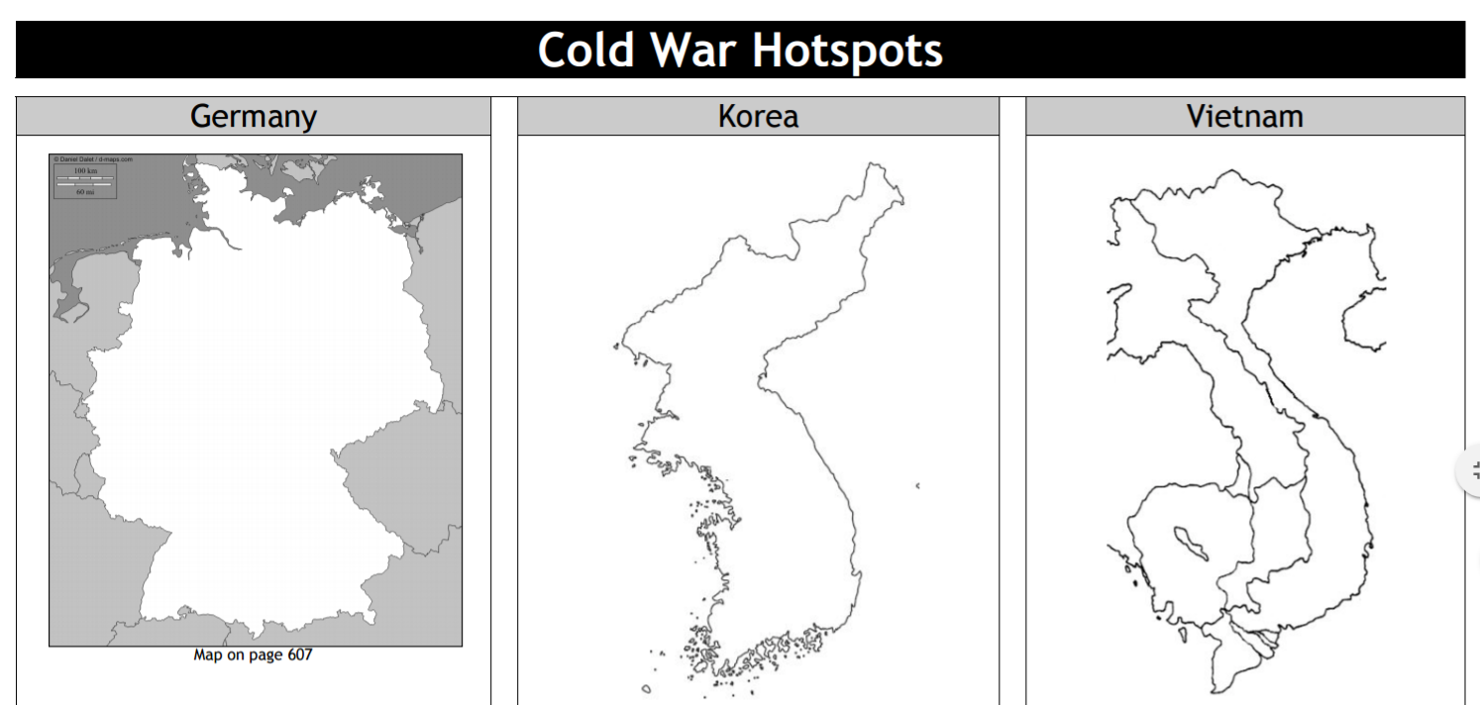

Socials 10/Ms. Rusk Name:__________________________
COLD WAR MAP ASSIGNMENT
There are FIVE maps that need to be completed for this assignment. Please note, that each map requires you to label and colour.
COLD WAR EUROPE MAP
Step 1: Label and colour according The Warsaw Pact Member Countries, Communist Nation outside Soviet Bloc, Neutral nations (non-aligned), and NATO members. Use 4 different colours to indicate these in the legend on the right. Use the map in the Socials 10 handouts on my website:
skssrusk.weebly.com * Yugoslavia is the Communist Nation outside Soviet Bloc, so should not be coloured as non-aligned.
* Figure out what category Iceland is and label and colour accordingly.
/29
*Cyprus and Malta were NATO members during the Cold War
*Put your colour choices in the ‘key’
/2
Step 2: Water: Lightly shade around Europe and colour in inland water bodies with blue.
/2
Step 3: Red Political Borders: use these to separate between alliances.

COLD WAR ASIA MAP

Step 1: Label and individually colour the following nations:
-JAPAN -U.S.S.R. -NORTH KOREA -SOUTH KOREA
-CHINA -TAIWAN -VIETNAM -LAOS
-KAMPUCHEA* -THAILAND -MONGOLIA -BRUNEI
-INDONESIA -PHILLIPINES -SINGAPORE -PAPUA NEW GUINEA (Draw in)
/32
-MALAYSIA -BURMA -BANGLADESH
-INDIA -BHUTAN -NEPAL -SRI LANKA
-EAST TIMOR -SYRIA -ISRAEL -JORDAN
-IRAN -IRAQ -KUWAIT -TIBET (draw in)
-AFGHANISTAN
*CAMBODIA
/2
Step 2: Draw in Egypt and individually colour.
/2
Step 3: Lightly colour countries that you are not asked to label grey.
/2
Step 4: Water: Lightly shade around Asia and colour in inland water bodies with blue.
Step 5: Red Political Borders: use these to separate between countries.
/2
Step 6: Create a legend.
/5

GERMANY COLD WAR HOTSPOT MAP:
/4
Step 1: Colour and label the 4 zones of occupation (see my handouts section on my website)
/4
Step 2: Create a legend to identify your colours.
/7
Step 3: Label East and West Berlin, Potsdam, Frankfurt, Munich, Bonn, and Nuremberg
Step 4: Indicate with a heavy dashed line the division between East Germany and West Germany
/2

KOREA COLD WAR HOTSPOT MAP:

Step 1: Label the following and colour Korea

-Yalu River -extent of North Korean advance
/12
-Pyongyang -extent of United Nations advance
-Seoul -extent of Chinese advance
-Pusan -eventual cease fire line
Total of text boxes: /121
Overall /20

Total: /141
-Inchon -38th Parallel
-Panmunjom
/2
Step 2: Lightly shade around Korea with blue.

VIETNAM COLD WAR HOTSPOT MAP:

Step 1: Label the following. Colour Vietnam, Kampuchea, and LAOS different colours.
/10
-VIETNAM -LAOS -KAMPUCHEA
-Da Nang -Ho Chi Minh Trail
-Gulf of Tonkin -Mekong River -Mekong Delta -Dien Bien Phu
-17th Parallel
/2
Step 2: Lightly shade around French Indo-China with blue.

